Assignments

💻 Assignment 1: Basic Profile Card (HTML & CSS Focus)
This task focuses on semantic HTML structure and fundamental CSS styling (layout, typography, and colors).
Concept(s) Reinforced | Expected Time
HTML: Semantic tags (<header>, <footer>, <section>, <img>), lists (<ul>/<ol>), attributes. | 45 minutes
CSS: Basic selectors, Box Model (padding, margin, border), Flexbox (for alignment), colors, fonts.
Task Description
Create a static, responsive "Personal Profile Card" for an imaginary person (or themselves). Using Bootstrap or Material UI or Tailwind CSS is allowed.
- Structure (HTML):
  - The card must be contained within a single <div> or <article>.
  - Include a header with the person's name (<h1>).
  - Include an image (<img>) of the person.
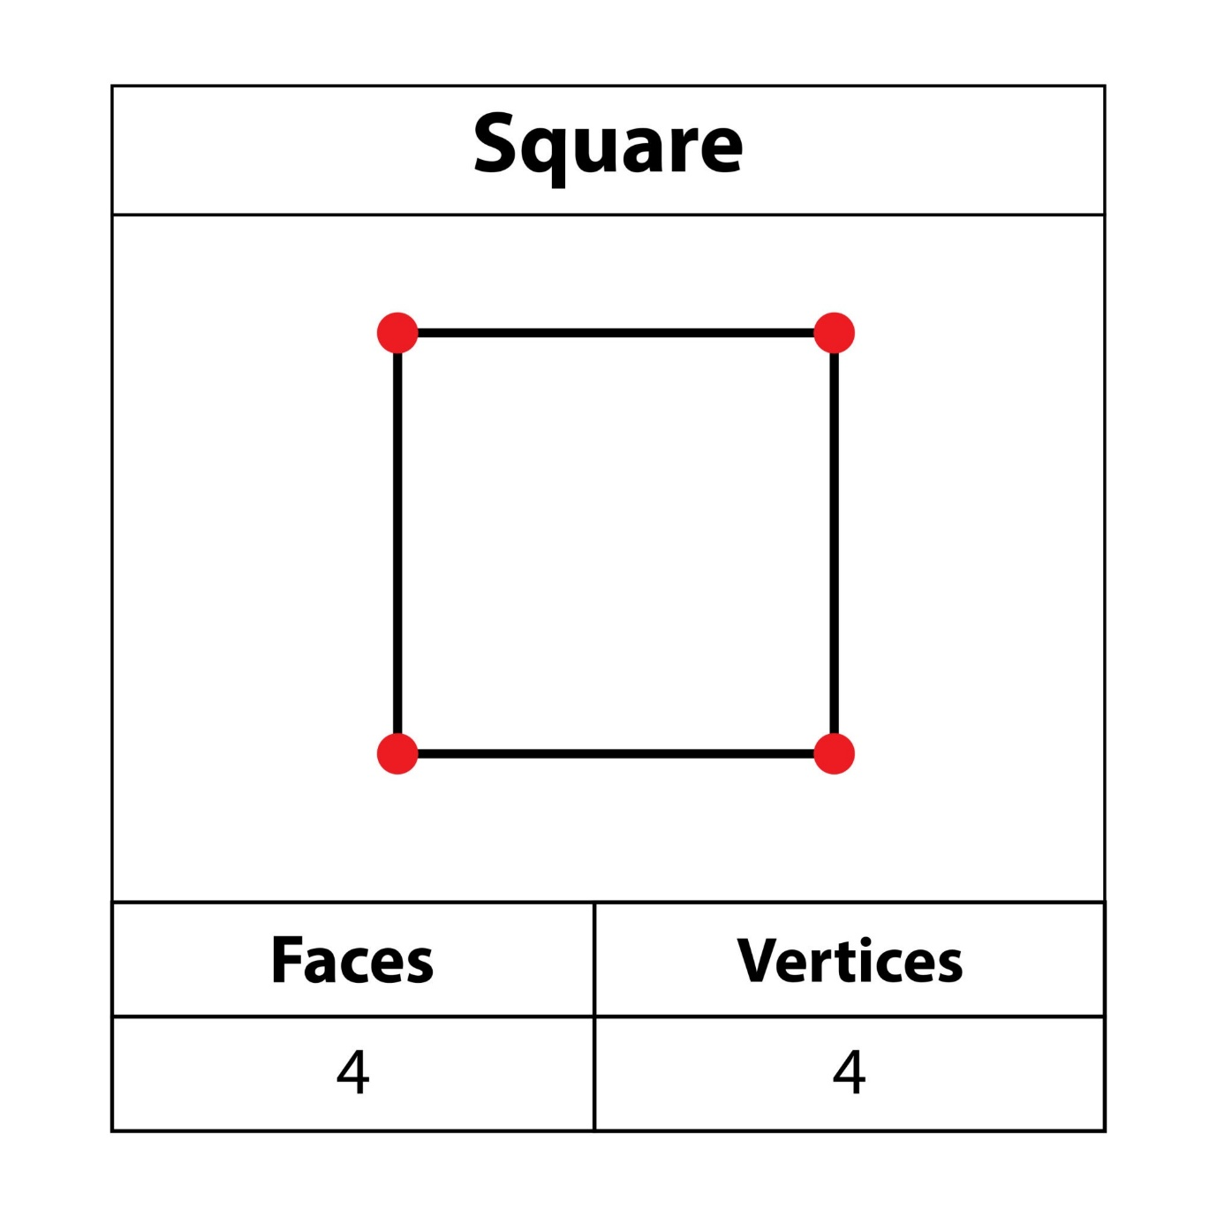
Getty Images
Explore
* Include a section with at least three skills listed as an unordered list (`<ul>`).
* Include a footer with a fake email address or link.
- Styling (CSS):
  - Use Flexbox to center the content on the screen horizontally.
  - Apply a distinct background color to the card and a different color to the body.
  - Use padding and margin to create clear spacing around the elements (demonstrating the Box Model).
  - Give the profile card a subtle box-shadow and a maximum width so it doesn't span the entire page.

🔢 Assignment 2: Simple Counter App (JavaScript Focus)
This task focuses on core JavaScript DOM manipulation and event handling.
Concept(s) Reinforced | Expected Time
JS: Variables, basic functions, DOM Traversal (getElementById/querySelector), Event Listeners (addEventListener), basic arithmetic. | 45 minutes
Task Description
Build a Simple Number Counter using HTML, CSS, and JavaScript.
- HTML Structure:
  - A display area (e.g., <h1> or <p>) to show the current count, initialized at 0.
  - A "Increase" button.
  - A "Decrease" button.
  - A "Reset" button.
- JavaScript Logic:
  - Declare a variable let count = 0; to store the current number.
  - Attach an event listener to the "Increase" button that increments the count by 1 and updates the HTML display.
  - Attach an event listener to the "Decrease" button that decrements the count by 1 and updates the HTML display.
  - Attach an event listener to the "Reset" button that sets the count back to 0 and updates the HTML display.

🎨 Assignment 3: Interactive To-Do Item (Combined Challenge)
This task integrates all three technologies for an interactive element.
Concept(s) Reinforced | Expected Time
All: Full workflow integration. | 30 minutes
HTML: Data attributes.
CSS: Simple class-based styling.
JS: Toggle functionality, manipulating element classes (classList.toggle()).
Task Description
Create a single To-Do List Item that can be marked as complete by clicking on it.
- HTML Structure:
  - A single <li> element containing a task description (e.g., "Buy groceries").
- CSS Styling:
  - Create a CSS class named .complete that applies a strikethrough (text-decoration: line-through) and a lighter color to the text.
- JavaScript Logic:
  - Add an event listener to the <li> element.
  - When the item is clicked, use JavaScript to toggle the .complete class on and off the <li> element. This should visually mark the item as done or undone.

